PUBMED (79)
#1 “peripherally inserted central catheter”
#2 “peripherally inserted central catheters”
#3 PICC
#4 central catheter
#5 central catheters
#6 #1 OR #2 OR #3 OR #4 OR #5
#7 “infant, newborn” [MeSH]
#8 newborn OR neonate OR neonat* OR infant OR newborn* OR low birth weight OR LBW OR VLBW
#9 #7 OR #8
#10 phlebitis [MeSH]
#11 phlebitis OR phlebophlogosis
#12 #10 OR #11
#13 #6 AND #9 AND#12

EMBASE (123)
No.
Query
Results
73
#14
#6 AND #9 AND #13
30,316
#13
#11 OR #12
11,536
#12
phlebitis OR phlebophlogosis
29,033
#11
'phlebitis'/exp
1,425,552
#9
#7 OR #8
1,425,552
#8
newborn OR neonate OR neonat* OR infant OR newborn* OR 'low birth weight' OR lbw OR vlbw
582,780
#7
'newborn, infant'/exp
51,255
#6
#1 OR #2 OR #3 OR #4 OR #5
15,860
#5
central AND catheters
47,523
#4
central AND catheter
3,685
#3
picc
1,245
#2
'peripherally inserted central catheters'
3,356
#1
'peripherally inserted central catheter'/exp OR 'peripherally inserted central catheter'

CENTRAL (37)
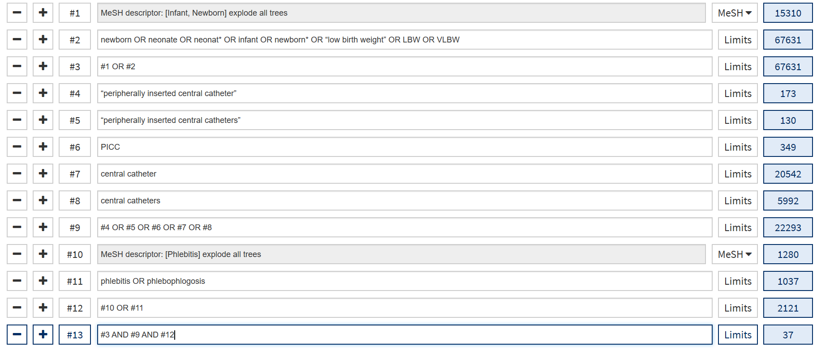

CINAHL (n=26)

S13 | S6 AND S10 AND S12
S12 | phlebitis OR phlebophlogosis
S11 | MH phlebitis
S10 | S8 OR S9
S9 | newborn OR neonate OR neonat* OR infant OR newborn* OR "low birth weight" OR LBW OR VLBW
S8 | MH infant, newborn
S7 | newborn, infant
S6 | S1 OR S2 OR S4 OR S5
S5 | central catheters
S4 | central catheter
S3 | PICC
S2 | “peripherally inserted central catheters”
S1 | “peripherally inserted central catheter”

CNKI (99)
SU= (('newborn' + 'premature' + 'low birth weight') * ('PICC' + 'peripherally inserted central catheter' + 'peripherally inserted central venous catheter') * ('complication' + 'phlebitis')

WANFANG (284)
(Subject: (Newborns) OR Subject: (Premature) OR Subject: (Low birth weight)) AND (Subject: (PICC) OR Subject: (peripherally inserted central catheter) OR Subject: (peripherally inserted central venous catheter)) AND (Subject: (Complication) OR Subject: Phlebitis))

CBM (84)
("PICC"[common field] OR " peripherally inserted central venous catheter "[common field] OR " peripherally inserted central venous catheter "[common field]) AND (("Newborn"[common field] OR "Infant, newborn"[common field] OR "Infant, Newborn"[subject line]) OR "Preterm"[common field] OR "Low Birth Weight"[common field]) AND ("Complication"[common field] OR "Phlebitis"[common field])

